Immigration, Policy Exclusion, and State-Level Inequality in TANF Usage
Supplementary Material

In this Supplementary Material, we present (1) diagnostic analyses pertaining to our model specification and results based on alternative model specifications, and (2) robustness checks results.
- Data Diagnosis and Alternative Model Specifications
We present our data diagnosis process and alternative model specifications to illustrate the process by which we choose the generalized ECM specification in our manuscript. We use Citizen-Immigrant TANF Caseload Gap as the main dependent variable in models presented in this section. We conducted a similar process of data diagnosis for Immigrant TANF Caseload Rates. Our Cross Section and Time Series (CSTS) data contain cases for 49 states and 16 years. We start with a simple OLS model and then estimate the fixed effect and random effect models. In the end, we estimate the dynamic error correction models.
OLS, FE and RE Models Comparison
We start with a simple static OLS model and the results are presented in Table 1 Model (1). The OLS model is based on complete pooling, we include the OLS specification so that we can show how results might change while adding fixed effects, random effects, and dynamic specifications. In Table 1, we present two fixed effect (FE) models to compare with the OLS model. FE models go beyond OLS by estimating within-state effects, either by including a full set of unit dummies or mean-centering all the right-hand variables (Greene, 2011; Allison, 2009; see also Zhu, 2013). We reported both types of fixed effect models. Below Table 1 Model (2) uses the technique of mean-centering the dependent variable, while Table 1 Model (3) includes a full set of state dummies. Comparing results from the OLS (which assumes unit homogeneity) and the two fixed effect models (which assume unit heterogeneity), we notice that coefficients have changed substantially when we move from the OLS model to the FE models. Such differences verify that our data are sensitive to model specifications. We reason the differences are owing to the fact that the OLS model is unable to consider unit heterogeneity.
The FE models, although better than OLS, are often criticized because they consume too much cross-sectional variation. In other words, although researchers could tell from the FE models whether or not cross-sectional variation exists, they cannot tell what causes the cross-sectional variation (Zhu, 2013). A core theoretical argument of our paper is that state immigrant TANF policy and state-level immigrant population could explain the cross-state variation of our dependent variable (i.e., Citizen-Immigrant TANF Caseload Gap), but the state dummies in the FE model might absorb most of the cross-state variation and cause null findings in our independent variables. When we look at the results of the FE models, we discover that Model (3) with the state dummies have a between R-square of 1. This shows that when we include state dummy variables in Model (3), these dummy variables have indeed absorbed almost all of the cross-state variation.
Unlike the FE models, which include state dummies as regressors, the random effects (RE) model includes an intercept that can randomly deviate from the mean intercept. Table 1 Model (4) presents the results of the RE model. Different from the FE model, the RE model leaves room for substantive independent variables to explain cross-state variation without including state dummies. However, this type of model requires that the random intercept does not correlate with the left-hand-side variables; otherwise, the RE model estimation will be inconsistent and inefficient. We can use the Hausman test to evaluate whether or not FE and RE models generate consistent and efficient results (Hausman, 1978). The Hausman test, comparing the results of the FE model with the technique of mean-centering the dependent variable and the RE model, generates a chi-square of
28.14 (p=0.003). The result shows that the RE model is not consistent and generates biased estimations.

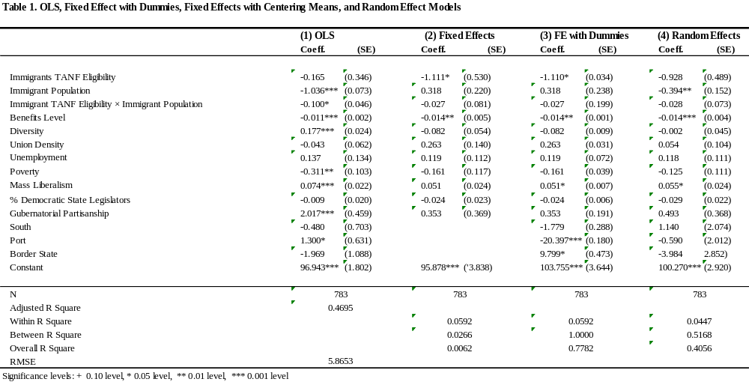
In sum, we discover that our data do not have complete poolability, thus OLS is not appropriate. The FE models absorb almost all cross-state variation and the RE model does not generate consistent/efficient results; therefore, both the FE and RE models are excluded from consideration.
Temporal dependency of our data
We also diagnosed the temporal dependency of our dependent variable. Many political and policy variables such as institutions, public policies, and government spending often bear long-term memory or in other words, their current value is dependent upon their past values. One important task of panel data analysis is to diagnose whether or not the dependent variable has a stationary process. To explain stationarity mathematically, we use the following equation to specify the relationship between the current and past values of our dependent variable: Y_{i,t}= a ×Y_{i,t-1} + e_{i,t}. In this equation Y_{i,t} is the current value of variable Y, while Y_{i,t-1} is the past value for variable Y. If |a|<1, the time series of Y is considered stationary. If |a|=1, the variable is considered to have permanent memories (with a unit root) or is called non-stationary.
We can use a series of tests (i.e., the Augmented Dickey-Fuller unit root test, and Phillips-Perron test) to investigate the temporal dependency of our dependent variable (Dickey & Fuller, 1981; Phillips & Perron, 1988). In these tests, the null hypothesis is that at least one of the series in the panel data is non-stationary. We have used both the Augmented Dickey-Fuller and Philips-Perron unit root tests and have considered a linear term with and without trend, a first-order lag with and without trend, a second-order lag with and without trend. 11 out of 12 tests show strong evidence that our dependent variable Citizen-Immigrant TANF Caseload Gap does not contain a uni root and is stationary. The results of all 12 tests are presented in Table 2 below. Following DeBoef and Keele’s (2008) suggestion that a dynamic error correction model (ECM) can be used in data scenarios when one has stationary dependent variables, we decide to use the dynamic ECM model specification.
Table 2. Unit Root Tests Using Augmented Dickey-Fuller (ADF) and Phillips-Perron (PP) Tests

Tests | Chi-square | p-value
ADF, no trend, lag (0) | 480.249 | 0.000
ADF, no trend, lag (1) | 292.478 | 0.000
ADF, no trend, lag(2) | 130.228 | 0.031
ADF, trend, lag(0) | 534.906 | 0.000
ADF, trend, lag(1) | 281.153 | 0.000
ADF, trend, lag(2) | 108.602 | 0.309
PP, no trend, lag(0) | 480.249 | 0.000
PP, no trend, lag(1) | 467.639 | 0.000
PP, no trend, lag(2) | 467.363 | 0.000
PP, trend, lag(0) | 534.906 | 0.000
PP, trend, lag(1) | 517.861 | 0.000
PP, trend, lag(2) | 524.661 | 0.000

Detecting Outlier States
It is important to evaluate whether certain states cause unobserved heterogeneity which is not explained by the regressors in the model. Therefore, we decide to detect which states are “average states” explained by the model, and which ones are outlier states that require additional model considerations, by analyzing residuals after fitting a baseline OLS model. We used two methods to identify outlier states: first, we evaluate the standardized residuals, the Cook’s distance, to determine outlier states, and second, we run a weighted regression and use the estimated weights to identify outlier states as estimated weights will decrease as residuals increase. With these two methods, we identify the following states with a large standard residual or small weights: Florida, Hawaii, Indiana, Michigan, Minnesota, and Utah. Therefore, we include a dummy variable for each of these states in order to control the specific state heterogeneity not explained by the regressors in the model.
Comparing the Full ECM with More Restricted Models
DeBoef and Keele (2008) suggest that ECM is used in data scenarios such as when one has stationary dependent variables. They also suggest that researchers should always start with a full ECM and then use joint F tests to determine if more parsimonious dynamic specifications are appropriate. Following their suggestion and in order to make sure that a full dynamic model is necessary, we compare a full ECM with the Partial Adjustment model. The specifications of the two models are as follows:
General ECM model: ∆Y_{i,t} = a + b₁ × Y _{i,t-1} + b₂ × ∆X_{i,t} + b₃ × X _{i,t-1} + e _{i,t}
Partial Adjustment model: ∆Y_{i,t} = a + b₁ × Y_{i,t-1} + b₂ × X_{i,t} + e_{i,t}
To begin, we eliminate the first-difference terms of all control variables and use a joint F test to compare the general ECM and the restricted model. We have obtained a F statistics of 1.77 (p=0.08), indicating that the coefficients for the first-difference terms of the control variables are not significantly different from zero, or in other words the Partial Adjustment Model that excludes first-difference terms of all control variables is nested in a full ECM.
We then take a step further and estimate another restricted Partial Adjustment Model that excludes first-difference terms of all right-hand-side variables (i.e., independent variables and control variables). We conduct a joint F test and obtain an F statistics of 3.49 (p=0.0001). This result indicates that the coefficients for the first-difference terms of our independent variables are significantly different from zero, or in other words, this Partial Adjustment Model that excludes first-difference terms of all right-hand-side variables is not nested in a full ECM.
In conclusion, it is appropriate for us to exclude first-difference terms of the control variables, but not appropriate to exclude first-difference terms of our independent variables.
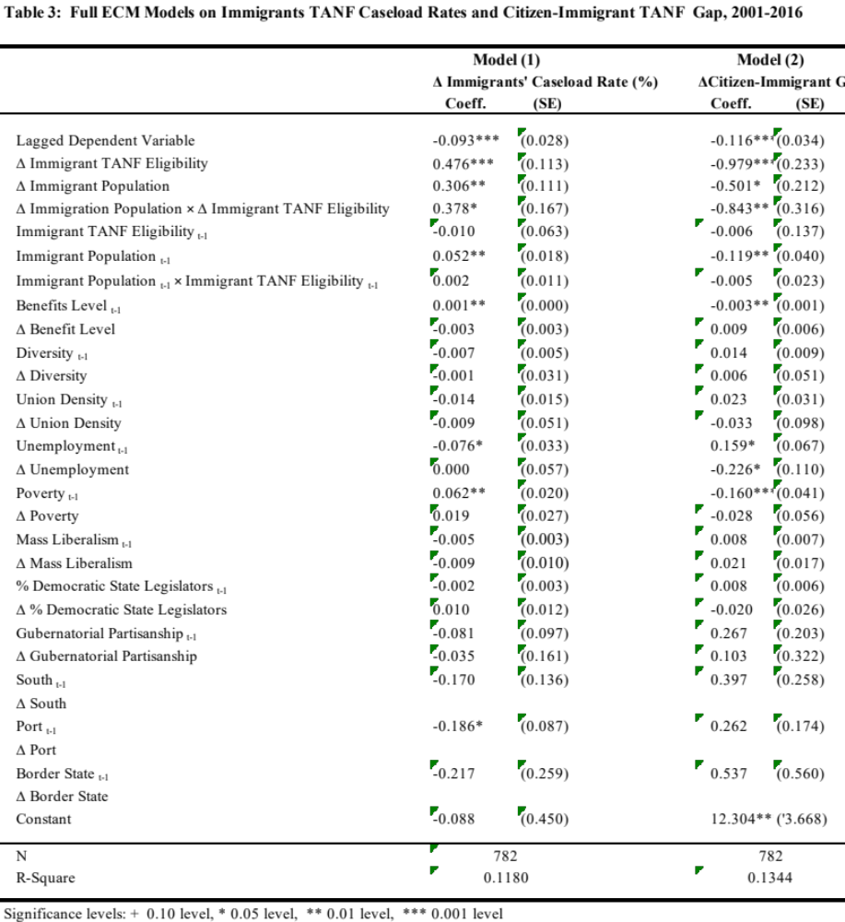
Therefore, we adopt a Partial Adjustment Model that only excludes the first-difference terms of control variables. We present the full error correction models in Table 3. Table 3 Model (1) uses ∆Immigrants’ TANF Caseload Rate as the dependent variable, and Table 3 Model (2) uses ∆Citizen-Immigrant TANF Caseload Gap as the dependent variable. Both models include the interaction terms. When comparing these models with the models in the paper (Table 1 Model (2) and Table 2 Model (2)), careful readers will find that the results are very similar, and the findings remain the same.

- Robustness checks results
In order to verify that our results are robust, we conduct two robustness checks. In the first robustness check, we replace our dependent variable, the Citizen-Immigrant TANF Caseload Gap, with a citizen-immigrant TANF gap measure based on the CPS self-reported TANF participation data. Figure 1(a) below shows the conditional effect of ∆ Immigration Population on the relationship between ∆ Immigrant TANF Eligibility and Δ Citizen-Immigrant Gap, and Figure 1(b) shows the conditional effect the other way. As one can see from Figure 1(a), in states with an increased immigrant population, ∆TANF Immigrant Policy has a negative relationship on ∆Citizen-Immigrant TANF Take-up Gap, suggesting that loosening up immigrant TANF eligibility rules can significantly reduce the citizen-immigrant TANF gap in these states. However, in states with a decreased immigrant population, ∆TANF Immigrant Eligibility has a positive effect on ∆Citizen-Immigrant TANF Take-up Gap, suggesting that in states with decreasing immigrant population, loosening immigrant TANF eligibility rules does not necessarily reduce the citizen-immigrant TANF gap, but instead could even increase the gap.
This robustness check shows further support for our H2-b, where we posit that the positive effect of exclusive immigrant TANF policy on the immigrant-citizen TANF participation gap should be weakened in states with a larger immigrant population. Indeed, in states with growing immigrant populations, a more generous TANF policy will lead to a reduction in the gap.
Figure 1: State Immigrant Policy, Immigrant Population, and Citizen-Immigrant TANF Participation Gap
(a) Effects of Change in Immigrant TANF Policy on Citizen-Immigrant TANF Participation Gap in States with Increased/Decreased Immigrant Population
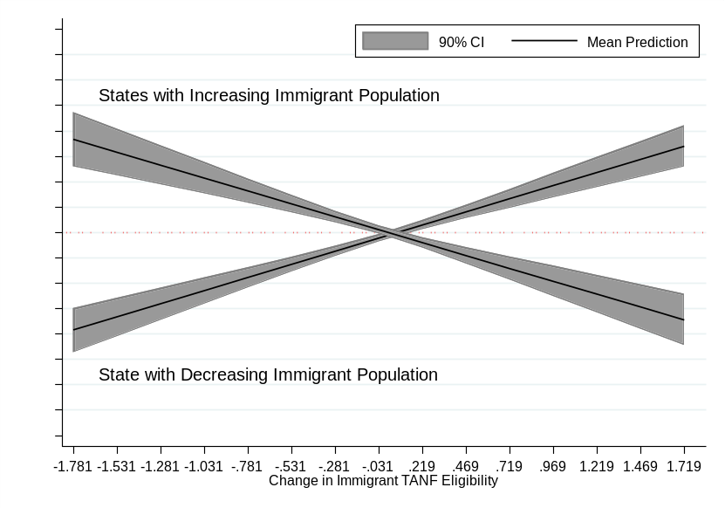
(b) Effects of Change in Immigrant Population on Citizen-Immigrant TANF Participation Gap in States with Tightened/Loosened TANF Immigrant Policies

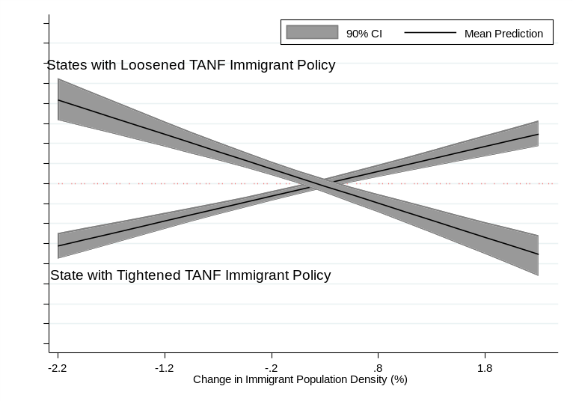
On top of the first robustness check, we further replace one of the key independent variables, immigrant population density, with two separate measures of immigrant political power. The first measure captures immigrant network strength and is measured by the number of immigrant advocacy groups divided by the immigrant population based on data from the Urban Institute National Center for Charitable Statistics (NCCS). The second measure captures immigrant voting power and is measured by the percentage of registered immigrant voters out of all registered voters based on the CPS November data. We use each of these two measures to replace the immigrant population density variable in the main model. Below Figure 3(a) and (b) show similar patterns. In states with a weaker immigrant network (or voting power), a state’s immigrant TANF policy from the previous year has a negative effect on the citizen-immigrant TANF participation gap. This suggests that in states with weaker immigrant political power, a more inclusive immigrant policy will help close the gap. However, in states with stronger immigrant political power, the effect is different. Generally, states with strong immigrant power will almost always see a reduction in the gap. However, it is when these states also see very exclusive immigrant policy in the previous year, the reduction in gap will be the most. This makes sense because in states with a very inclusive immigrant policy previously, the gap is small to begin with and there are fewer “improvements” that can be made. This result is still in line with our argument that immigrant political power conditions the effect of immigrant TANF policy on the citizen-immigrant TANF participation gap. We decide to use immigrant population density in the main model because it can serve as a proxy to capture both immigrant network and voting power.

Figure 2: State Immigrant TANF Policy, Immigrant Political Power and Citizen-Immigrant TANF Participation Gap
(a) Effects of Immigrant TANF Policy (t-1) on Change in Citizen-Immigrant TANF Participation Gap in States with Stronger/Weaker Immigrant Network
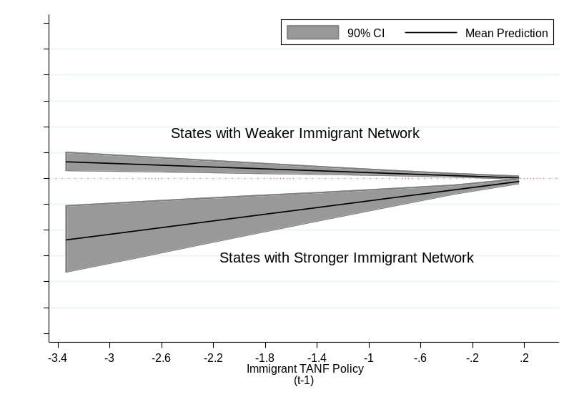
(b) Effects of Immigrant TANF Policy (t-1) on Change in Citizen-Immigrant TANF Participation Gap in States with Stronger/Weaker Immigrant Voting Power

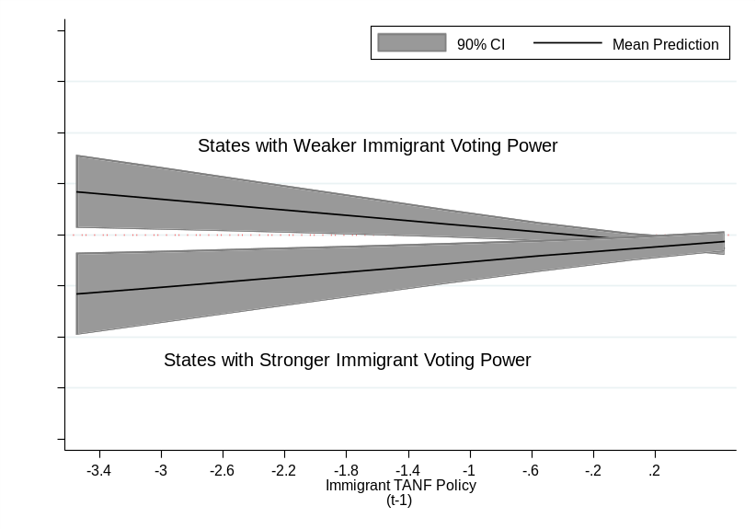

Work Cited:
Allison, P. (2009). Fixed-effects regression models Quantitative applications in the social sciences. Thousand Oaks, CA: Sage Publications.
De Boef, S., & Keele, L. (2008). Taking time seriously. American Journal of Political Science 52, 184–200.
Dickey, D. A., & Fuller, W. A. (1979). Distribution of the estimators for autoregressive time series with a unit root. Journal of the American Statistical Association, 74, 427–431.
Greene, W. (2011). Econometric analysis (7th Edition ed.). New York: Prentice Hall.
Hausman, J. A. (1978). Specification tests in econometrics. Econometrica, 46, 1251-1271.
Phillips, P. C. B., & Perron, P. (1988). Testing for a unit root in time series regression. Biometrika, 75, 335–346.
Tumlin, K. C., Zimmermann, W., & Ost, J. (1999). State snapshots of public benefits for immigrants: A supplemental report to `patchwork policies': The Urban Institute.
Zhu, L. (2013). Panel data analysis in public administration: Substantive and statistical considerations. Journal of Public Administration Research and Theory, 23, 395-428.

