Supplementary Materials

In this Supplementary Materials document, we present additional details on: (1) the descriptive statistics of our key variables, (2) additional analyses when using sub types of online political participation as dependent variables.
- Descriptive Statistics on key variables
Below, we present the mean, standard deviation, minimum and maximum values of our key variables.

Table 1. Descriptive Statistics of Key Variables

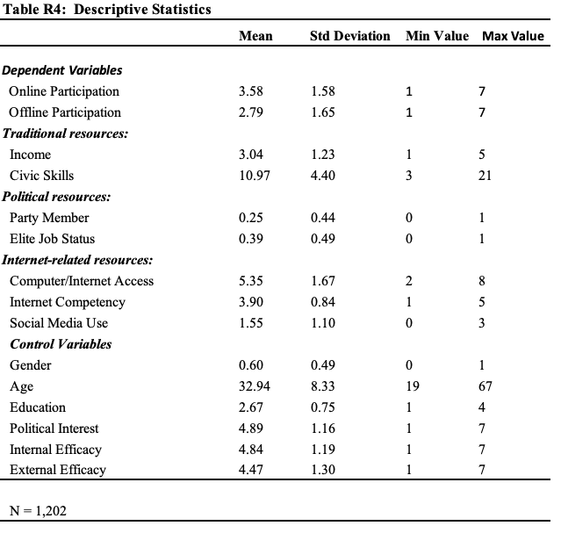

- Additional analyses when using sub types of online political participation as dependent variables.
In order to double check whether Internet-related resources (Computer/Internet Access, Internet Competency and Social Media Use) have a significant effect on each of the sub-type of online participation, we broke down online participation into its sub-types and ran the same analyses by using the sub types as dependent variables. The results are presented in the table below. The results show that social media have a positive and significant effect on both “Offer Suggestions to Governmental Officials Online” and “Post or Reppost Political Commentaries Online.” Multi-point Computer/Internet Access helps citizens with “Monitoring Policy making Online.”

